# **ECEN 215 – PRIN OF ELECTRICAL ENGR**

# **Spring 2019**

## **Lab 5: Introduction to AC Signals**



**Submitted by:**

|  |  |  |
| --- | --- | --- |
| **Student Name** | **UIN:** | **Section #** |
| Daniel Lopez | 426001591 | 516 |
| Adam Johnston | 516007336 |
| Jared Blunt | 524009660 |  |

**Date Performed: March 18th, 2019**

1. **Objective**

This lab’s purpose is to serve as an introduction to Alternating-Current (AC) circuits; it shows how amplitude, frequency, and phase shift all affect AC circuits. It also allows a check of how KVL is still applicable and true in AC circuits. To do this, these circuits are first simulated using MultiSim software, which gives their theoretical values. Then they are recreated on breadboards and tested; so that instead of ideal values, true, “real life” figures can also be produced and used for comparison to their theoretical counterparts

1. **Procedure**
2. Measure and record minimum and maximum resistance.
3. Built the circuit and measure both Vin and Vout, also records what happens to the phase shift as the resistance changes.
4. Set the resistance to its maximum then measured and recorded the time shift and used it to calculate the phase shift.
5. Screenshot the input and output in WaveForms.
6. Measure the RMS voltage of the source, potentiometer, and the capacitor.
7. Made sure the KVL applies for the measurements made in the experiment.
8. **Difficulties**
9. Damaged components
10. Components with different values than what was needed for the lab
11. Being unable to measure individuals inductors
12. Difficulty keeping wires inside the Analog Discovery
13. Issues with the WaveForms software giving incorrect data
14. Interpolating data from the WaveForms software
15. **Results**

**Measured Values**

|  |  |  |
| --- | --- | --- |
| **Component** | **Theoretical** | **Actual** |
| **Vsource** | 2 V | 2 V |
| **Capacitor** | 10 uF | 10.94 |
| **Potentiometer** | N/A | [0.2, 493.5] Ohm |
| **Frequency** | 50 Hz | N/A |

**Min Resistance**

|  |  |
| --- | --- |
| **Component** | **Voltage (peak)** |
| **Vin** | 2 V |
| **Vout** | 2 V |

**Max Resistance**

|  |  |
| --- | --- |
| **Component** | **Voltage (peak)** |
| **Vin** | 2 V |
| **Vout** | 1.031 V |

**Phase Shift (Max Resistance)**

|  |  |
| --- | --- |
| **Δt** | 3.338 ms |
| **Phase Shift (360o x Δt x Frequency)** | 60.084o |
| **(Vin)RMS** | 1.413 V |
| **(Vout)RMS** | 0.729 V |

**Screenshots from WaveForms**

**Minimum Resistance (0.2 Ohm)**

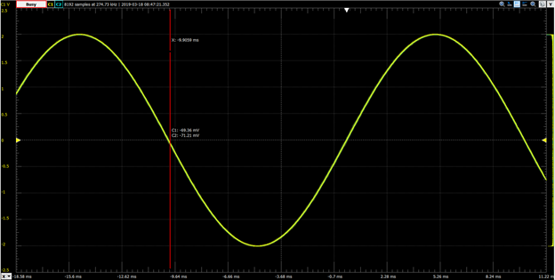

**Maximum Resistance (493.5 Ohm)**

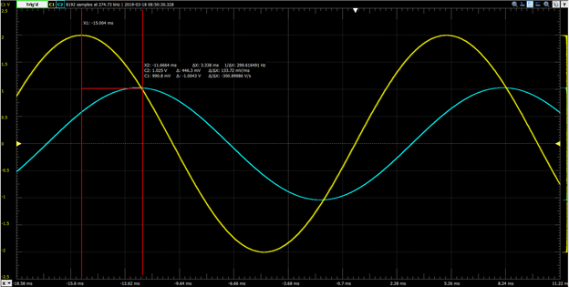

**RMS**

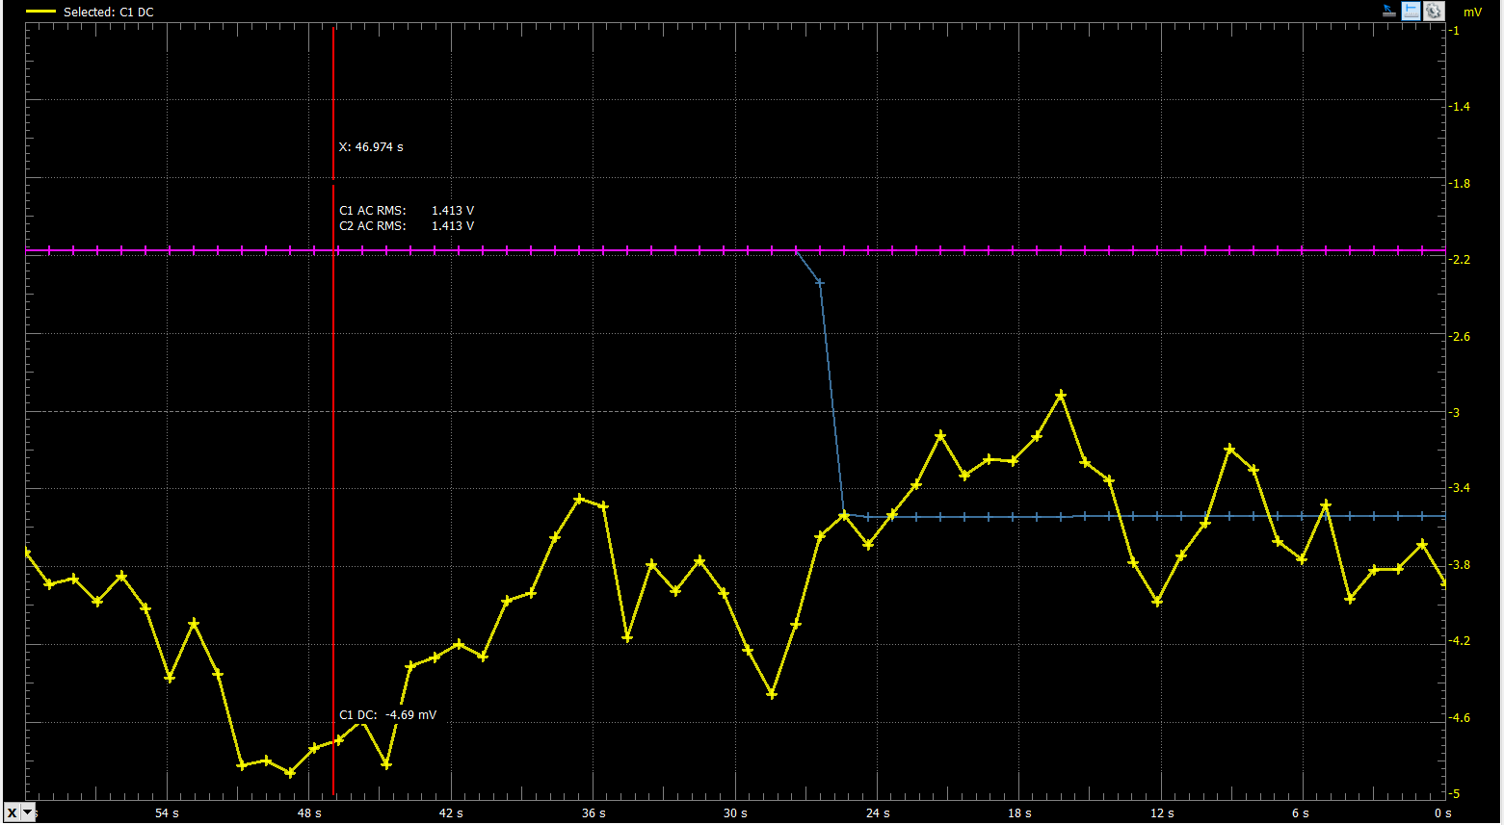

**Pink: Vin**

**Blue: Vout**

**Hand Calculations**

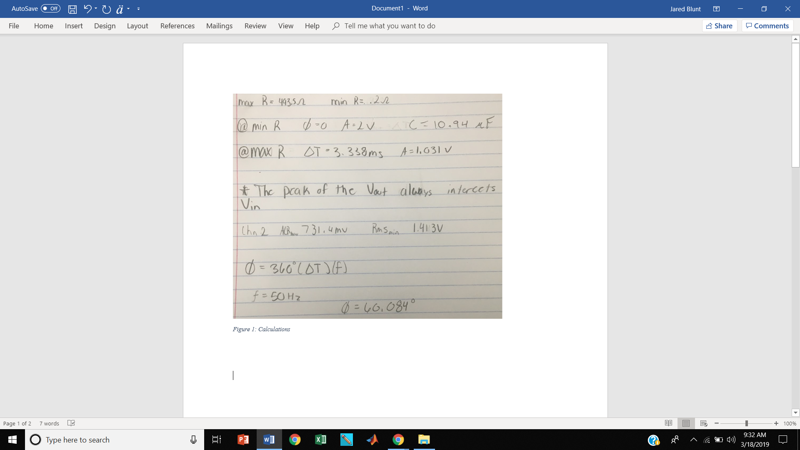

**Circuits**

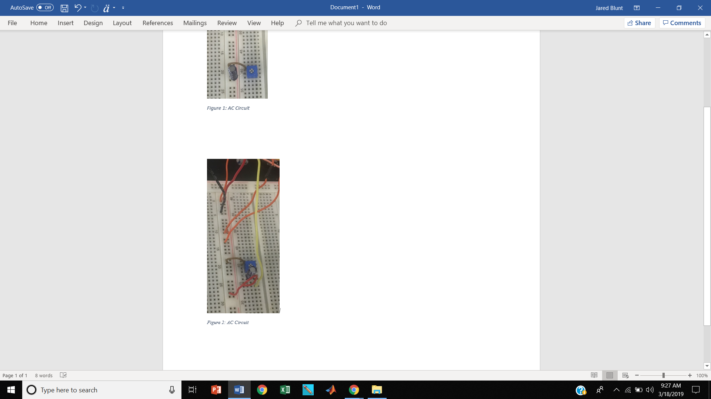

1. **Conclusion**

By using an A/C power source connected to a potentiometer and capacitor in series, we were able to control the phase shift of the voltage across the capacitor by adjusting the potentiometer. This makes sense because by adjusting the resistance of the circuit we are changing the imaginary component of the phase diagram, which in turn changes the phase of the voltage. We also noticed when observing the oscilloscope that the peak of the voltage across the capacitor always intersects the WaveForms of the voltage source.